Database tables

Admin login

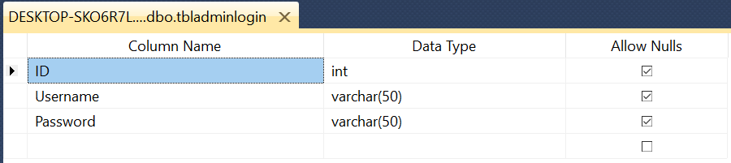

Adding students and teachers according to their respective class

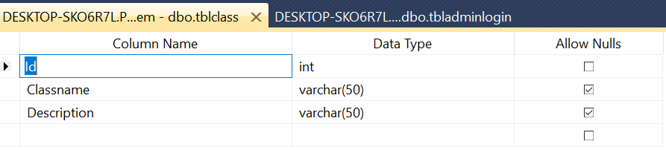

Adding deadlines and Project and assigning to teacher and student

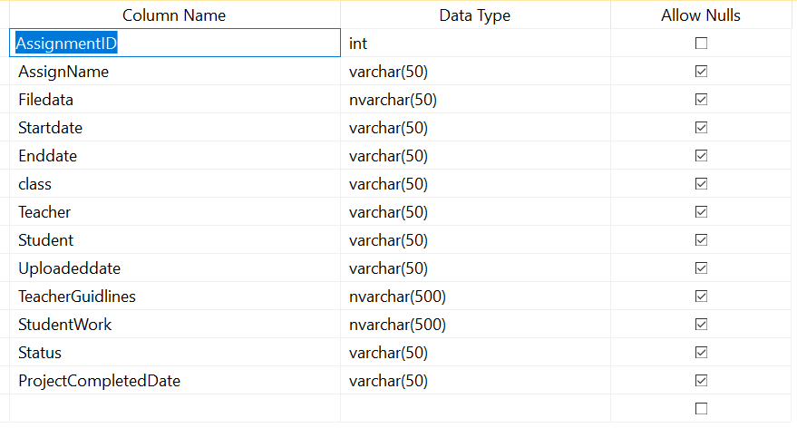

Uploading the list of holidays

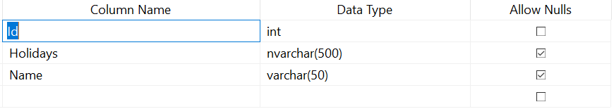

Creating report

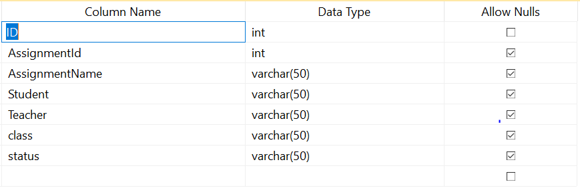

Messages can be sent to the student

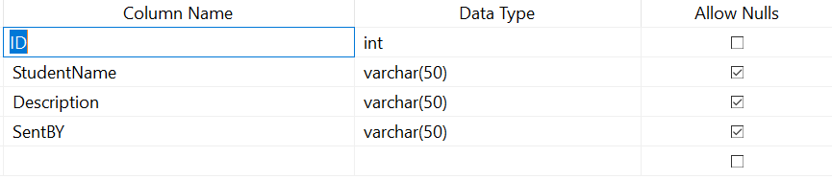

Remainders can be sent to the student

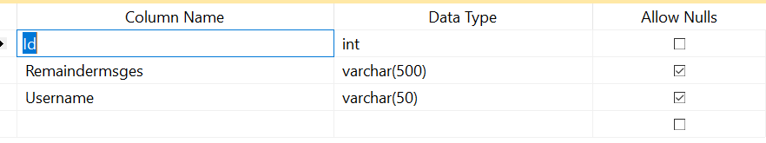

Admin Adding the Teacher

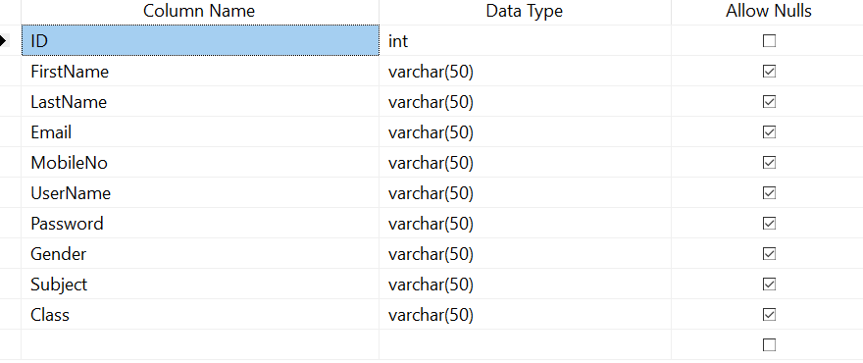

Admin Adding the student

